ASSIGNMENT NO. 2
Title :
Study and Demonstration of Git and GitHub Commands Using Terminal

1. Aim
To study Git and GitHub and demonstrate commonly used Git commands for creating, managing, tracking, and synchronizing a project repository using the terminal.

2. Introduction
Git is a distributed version control system (DVCS) used to track changes made to files during software development. It allows developers to maintain different versions of a project and return to previous versions whenever required.
Git works locally on a computer, so most Git operations can be performed without an internet connection. Developers can create commits, branches, and view the history of a project locally.
GitHub is a cloud-based platform that provides remote hosting for Git repositories. It allows developers to store their projects online, collaborate with other developers, share source code, and maintain project history.
Git and GitHub are commonly used together. Git manages the version history locally, while GitHub can be used to store and synchronize the repository remotely.

3. Basic Git Concepts
Repository
A repository is a location where Git stores the files and complete version history of a project. A repository can be local or hosted remotely on platforms such as GitHub.
Working Directory
The working directory contains the actual project files on which the developer is currently working.
Staging Area
The staging area is an intermediate area where changes are placed before they are committed. The git add command is used to move changes to the staging area.
Commit
A commit is a saved version of the changes made to a project. Each commit has a unique identifier and a commit message describing the changes.
Branch
A branch is an independent line of development. Branches allow developers to work on new features or modifications without directly affecting the main project.
Remote Repository
A remote repository is a version of the project stored on a remote server such as GitHub. The local repository can be synchronized with the remote repository using commands such as git push and git pull.

4. Git Workflow
The basic Git workflow can be represented as:
Working Directory → Staging Area → Local Repository → Remote Repository
- Files are created or modified in the Working Directory.
- git add moves the required changes to the Staging Area.
- git commit saves the changes in the Local Repository.
- git push uploads committed changes to the Remote Repository on GitHub.
- git pull downloads the latest changes from the remote repository.

5. Software Requirements
- Windows Operating System
- Git
- VS Code / Git Bash
- GitHub Account
- Internet Connection

6. Git and GitHub Commands
1. Check Git Version
git --version
Purpose: Checks whether Git is installed and displays the installed version.

2. Configure Git Username
git config --global user.name "sarvadnyshelke"
Purpose: Sets the username that will be associated with Git commits.

3. Configure Git Email
git config --global user.email "sarvadnyshelkegmail.com"
Purpose: Sets the email address associated with Git commits.

4. Create a New Directory
mkdir GitAssignment
cd GitAssignment
Purpose: Creates a new directory for the project and moves into it.

5. Initialize Git Repository
git init
Purpose: Converts the current project directory into a Git repository.

6. Check Repository Status
git status
Purpose: Shows the current state of the working directory and staging area.

7. Add Files to Staging Area
git add .
Purpose: Adds all modified and untracked files to the staging area.

8. Commit Changes
git commit -m "Initial commit"
Purpose: Saves the staged changes as a new version in the local repository.

9. View Commit History
git log --oneline
Purpose: Displays the previous commits in a short format.

10. Check Branches
git branch
Purpose: Displays the branches available in the repository.

11. Create a New Branch
git branch feature
Purpose: Creates a new branch named feature.

12. Switch Branch
git switch feature
Purpose: Switches from the current branch to the feature branch.

13. Switch to Main Branch
git switch main
Purpose: Switches back to the main branch.

14. Connect Local Repository to GitHub
git remote add origin https://github.com/sarvadnyshelke/fullstack.git
Purpose: Connects the local repository to the user's remote GitHub repository.
GitHub Repository:
https://github.com/sarvadnyshelke/fullstack.git

15. Check Remote Repository
git remote -v
Purpose: Displays the URL of the remote repository connected to the local repository.

16. Rename Branch to Main
git branch -M main
Purpose: Renames the current branch to main.

17. Push Repository to GitHub
git push -u origin main
Purpose: Uploads the committed changes from the local repository to the main branch on GitHub.

18. View Changes
git diff
Purpose: Displays the differences between the current files and the last committed version.

19. Pull Changes from GitHub
git pull
Purpose: Downloads the latest changes from the remote GitHub repository and integrates them into the local repository.

20. Clone a GitHub Repository
git clone https://github.com/sarvadnyshelke/fullstack.git
Purpose: Creates a local copy of the existing repository hosted on GitHub.

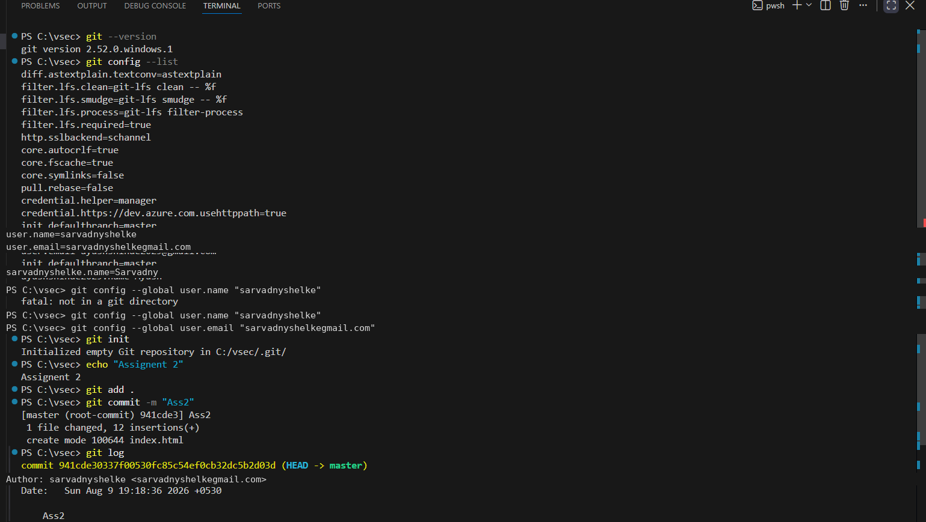
7. Terminal Screenshots
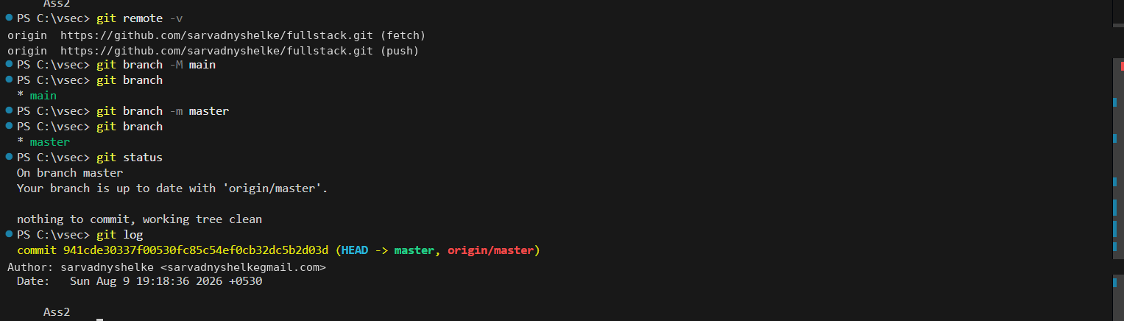

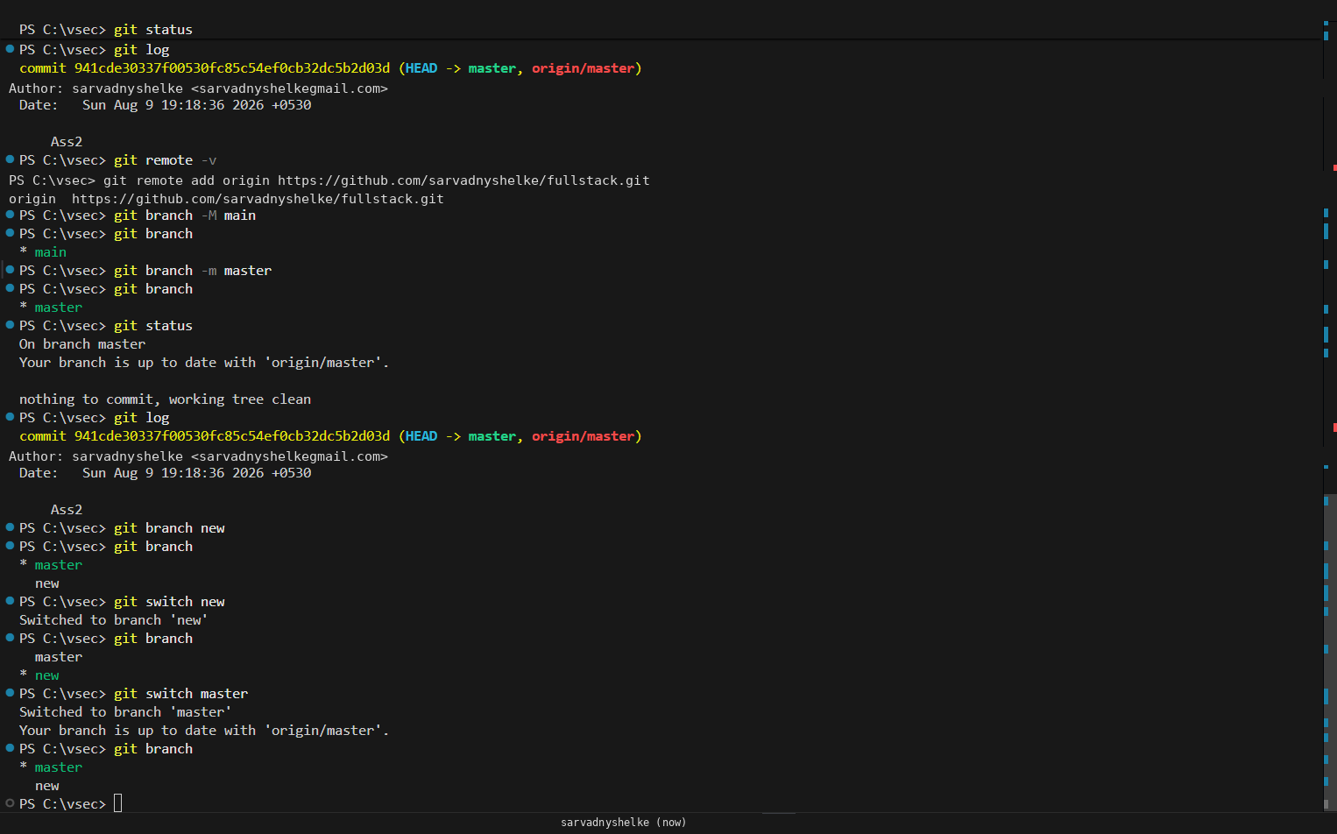
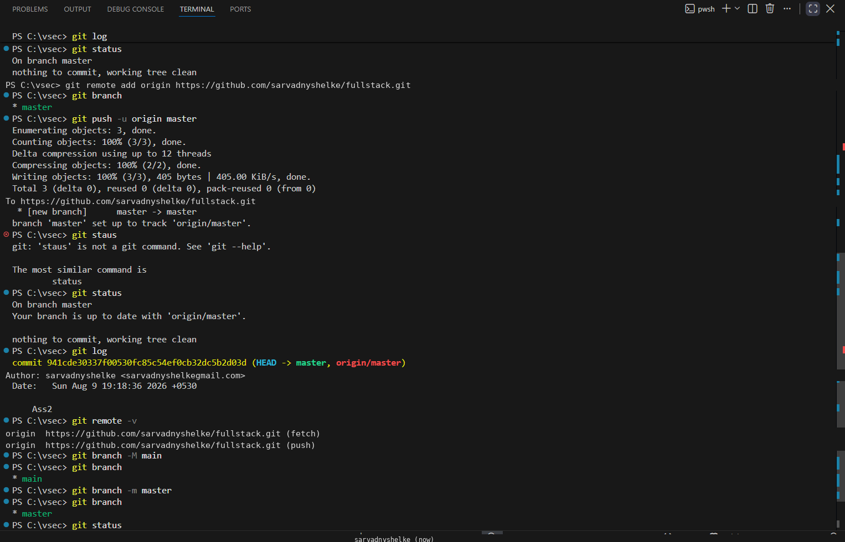

8. Conclusion
Git provides an effective method for version control and helps developers track changes made to a project. GitHub provides remote repository hosting and supports collaboration and sharing of projects. Through this experiment, the basic Git workflow and commonly used Git and GitHub commands were successfully demonstrated using the terminal.

